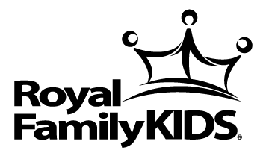
ROYAL FAMILY KIDS CAMP
at Camp Asbury (Silver Lake, New York)
Sponsored by the Houghton Wesleyan Church (Houghton, New York)

LETTER OF REFERENCE

Royal Family Kids’ Camp is a one-week residential camp for abused and neglected children, ages 6 to 12. Each year we assemble a team of 30 staff and 26 counselors to provide positive memories for these children who are referred to us from county social service agencies. Each counselor has direct responsibility for two campers. Staff members interact more generally with all 52 children in such capacities as art, drama, singing, recreation, crafts, etc.

APPLICANT INFORMATION

___________________________________________________________
Last Name First Name

How long and in what capacity have you known the applicant?

______________________________________________________________________________________
______________________________________________________________________________________
______________________________________________________________________________________

Have you directly observed this applicant working with children? If yes, please describe briefly.

______________________________________________________________________________________
______________________________________________________________________________________
______________________________________________________________________________________

Is the applicant highly respected by you and others for their work with children? NO YES
If no, please comment below:

______________________________________________________________________________________
______________________________________________________________________________________
What degree of success do you believe the applicant will have working with a group of children, all of whom have been abused, abandoned, or neglected? Exceptional Above Average Average Below Average Poor

If you selected in the “Average” to “Poor”

______________________________________________________________________________________
______________________________________________________________________________________
______________________________________________________________________________________
Please provide any additional comments that would help us determine the applicant’s “goodness of fit” with a position of responsibility in a residential camp context with abused and neglected children.

______________________________________________________________________________________
______________________________________________________________________________________
______________________________________________________________________________________

YOUR INFORMATION

___________________________________________________________
Last Name First Name

______________________________________________________________________________________
Occupational title (or relationship to applicant)
(_______)_____________________________________________________________________________
Phone Email

______________________________ _______________________________ ____________________
Signature Name printed Date executed

PLEASE RETURN THIS FORM NO LATER THAN FEBRUARY 25 TO:
Nancy Murphy, Director
Royal Family Kids’ Camp
7448 Centerville Rd
Houghton, NY 14744
Houghton.RFKC@gmail.com

